# Revit Database Link

*(Updated 2012-12-26 by Jinsol Kim)*

|  |
| --- |
|  |
| The Database Link tool will consist of three main commands, Data Sync, Setup and Data Editor.  1. **Data Sync**: users can create a new database or synchronize with existing database.  2. **Setup**: users can create their own selection of data to export to the database.  - By Categories, Families, Parameters* and External Database  * By Parameters: users can create a selection of parameters that will be appeared in the Data Editor and determine whether the value of parameter will be editable or not in the Data Editor.  *By External Database: project parameters can be linked with values from external database.  3. **Data Editor**: through this UI, users can manipulate and record values of parameters using additional functions like calculation of parameters. |

Contents

Revit Database Link 1

1. Data Sync 3

2. Setup 6

2.1 Create New Database 6

2.1.1 Preview Images 6

2.1.2 Save File Dialog 7

2.1.3 Category and Family Type Selection 8

2.1.4 Parameter Settings 10

2.1.5 Reference Settings 13

2.1.5 Create Database File 16

2.2 Edit Settings 17

3. Data Editor 18

3.1 Home Tab 18

3.1.1 Opening Data Editor 18

3.1.2 Revit Hidden Properties 23

3.1.3 Reference Database 25

3.1.4 Calculated Fields 28

3.1.5 Synchronization in Data Editor 33

3.2 Filter Tab 37

Appendix A: Revit Hidden Properties (for instance tables only ) 39

Appendix B: Access Database Description 39

Appendix C: Category Definition 40

Appendix D: Revit Element Category 41

Appendix E: Revit Value AsString( ) vs AsDouble( ) 42

# 1. Data Sync



Phase 1: Reading default settings and find the file location of the linked database.

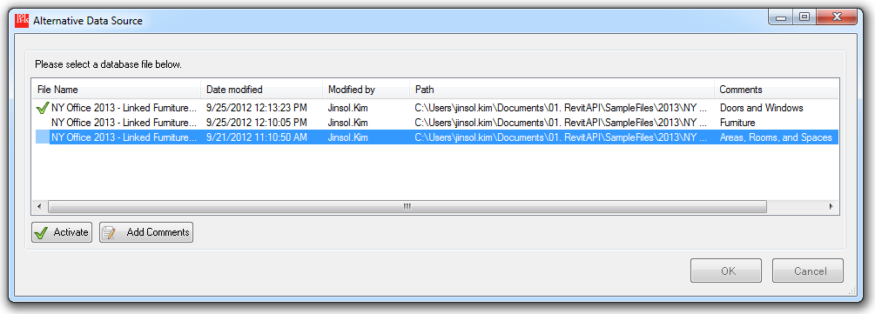

Phase 2: Collecting data of existing categories in the activated database file.

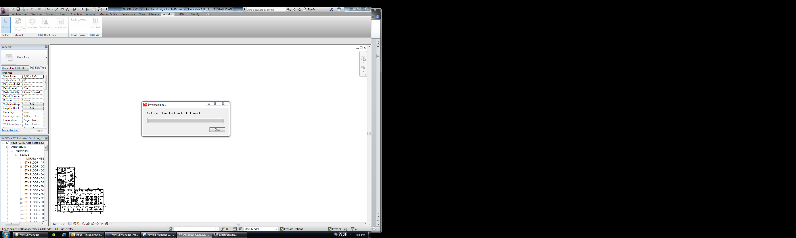

Phase3: Writing the collected Revit data in the database only in case of the following types of parameters: RevitControlled, ReadOnly, ViewOnly  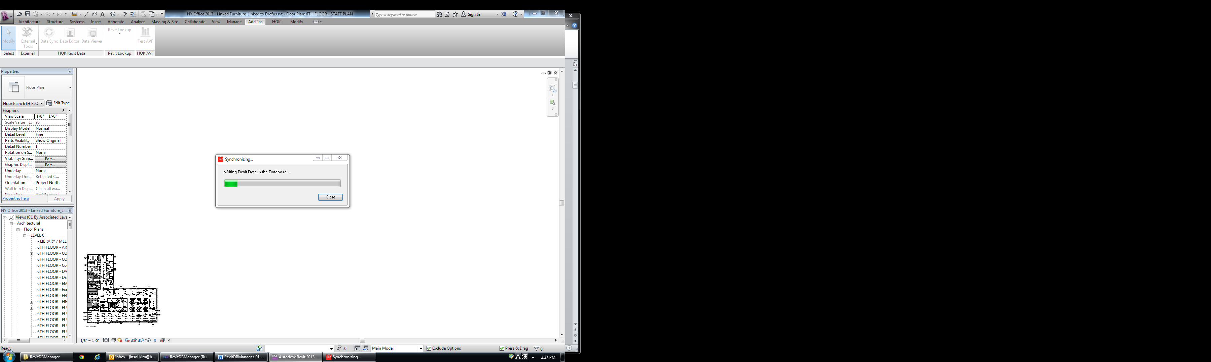

Phase4: Reading values of DatabaseControlled**** parameters from the database and setting the values to the corresponding parameters of Revit elements.

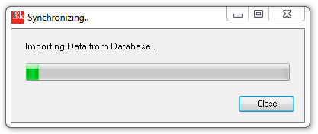

Phase5: Success message

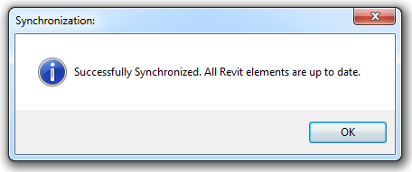

Synchronization: Parameter Type

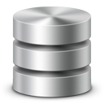





# 2. Setup



|  |  |  |  |
| --- | --- | --- | --- |
| Create New Database  2.1.1 Preview Images   Before opening the Editor, all preview images of element types will be saved into a designated location that will be same as the project located. From second trial of opening the Data Editor, it will skip this process if the required images already exist in the folder. 2.1.2 Save File Dialog   Designate file location to create a new database. 2.1.3 Category and Family Type Selection | | | |
|  | | | |
|  | | 1. Category: it will display all exisiting element types or objects within the following categories of lists. | |
| - Area**  - Ceilings ( System Family)  - Curtain Panels ( System Family)  - Doors (Component Family)  - Floors (System Family)  - Furnitures (Component Family)  - Furniture Systems (Component Family)  - Generic Model (Component Family)  - Mass (Component Family)  - Railings (System Family)  - Ramps (System Family)  - Roof (System Family) | - Rooms**  - Spaces**  - Specialty Equipment (Component Family)  - Stairs (System Family)  - Structural Foundation (System Family)  - Views**  - Walls (System Family)  - Windows (Component Family)  ** non-families treated as different structures of data |
| 2. FamilyType: depending on a selection of category, it will generate lists of family types belonging to the category.  3. Family Type Selection: by the add and remove buttons, it will collect selection of family types and display them in the list. | |
| Auto Sync Settings: Whenever new families or types are loaded into the Revit project, it will automatically include them into the selection of family types, if they are set the Auto Synchronization option as true.    -Auto Sync Category: Select a category and click the “Auto Sync Category” button. All families under the category will be moved to the Family Type Selection. Select the category item and click “Cancel” to disable the auto-synchronization.  -Auto Sync Family: Select a node with a family name and click the “Auto Sync Family” button. All family types under the family will be moved to the Family Type Selection. Select the family node and click “Cancel” to disable the auto-synchronization.  **If selected types by Auto sync is moved back to unselected states, the auto sync option will be automatically removed. | | | |
| 2.1.4 Parameter Settings | | | |
|  | 1. Families: it will display all selected families from the category tab page.  2. Exclude Instance Data  When only type information is required within a specific category, check the Exclude Instance Data check box so that the output only includes type parameter values.  3. Parameters:  When a category name is selected, it will display commonly existing parameters within the selected category. e.g.) “Model”, “Type Mark”, Keynote”, ..  When a family name is selected it will display specific parameters only exisiting in the selected family. e.g) Chamfered family, “Chamfer”, “Width”, “Depth”, …. | | |
| Visibility Settings:   Users may click the first column of the data grid view to show and hide the eye icon.  If the eye icon appears, it means the parameter will be displayed in the Data Editor. Read From Settings:    |  |  |  | | --- | --- | --- | | Read From | Description | isEditable | | Data Editor Read Only | It will be appear in the Data Editor as read only values | No | | Revit Controlled | It will be overwritten by values from Revit projet. | Yes | | Datatabase Controlled | It will be overwritten by values from Database | Yes | | Revit Read Only (*) | Revit ReadOnly Parameters | No |     User can change each read from settings by selecting parameters and click one of lock type buttons, or by selecting menus on mouse right-click.  *Note: Revit Read-only parameters cannot be changed with any Read From settings.*  *Default Setting: Visibiltity>>False ( Project Parameters: True) , Read From>>Revit Controlled* Parameter Properties:   User can look up parameter properties of a selected parameter by clicking a parameter in the lists. | | | |
| 2.1.5 Reference Settings | | | |
| 1. Browse an external database file. Click the browse button to open a file dialog.    2. Click Add Parameter-Field Relationship button  and Select one of pre-selected categories in the Category tab.    3. Define Controlling and Updating parameters and fields.  - Revit Parameters: The list box will only display with visible type parameters of which data type is string. **  This flag icon was marked on project parameters.  -External Database Fields: once a table name is selected among the list of tables of the linked database, all existing field names will be listed out below.  -Controlling Parameter and Field: select a parameter name and a field name, and click the upper  button  -Updating Parameter and Field: select a parameter name and a field name, and click the lower  button. The updating parameters and fields allows up to 5 maps. The sequence of the map can be modified by move up and move down button on the left-down corner, or removed from the list through delete button on right-down corner.  Rules for Controlling and Updating parameter-field maps   * **A category** of Revit can have **only one controlling parameter**. * **Only type parameters** can become either controlling parameters or updating parameters. * The **data type** of Controlling and updating parameters should be **String**. * **One controlling** parameter and field map can have up to **5 updating** parameter and field maps. * **A controlling parameter** can be either RevitControlled or DBControlled, but **updating parameters** should be DBControlled.     4. Select a parameter name and click Edit button  or Delete button  to modify the contents of the linked field 2.1.5 Create Database File Click “Apply” button in the UI to start creating a database file based on selections of family types and parameters with all settings. | | | |

|  |
| --- |
| 2.2 Edit Settings |
|  |

|  |  |
| --- | --- |
| |  | | --- | | 3. Data Editor |    3.1 Home Tab In the Home tab, users can modify Revit data from the data grid view and synchronize data between Revit and Database. |
| 1. File  - Data Source: choose one of alternative database to be displayed in the Data Editor.  -Sync: Synchronize data between Revit and the database file.  2. Revit Hidden Properties  - Pick: select hidden properties of Family Instance provided by Revit internal database.  -View: to make hidden properties visible in the Data Editor.  -Hide: to hide hidden properties in the Data Editor.  3. Reference Database  -View: to make linked fields visible in the Data Editor.  -Hide: to hide linked fields in the Data Editor.  4. Calculated Fields  -Concat: concatenation of strings using values from existing fields or constants.  -Math: math calculation between values from existing fields or constants.  -Delete: deleting expression from calculated fields. 3.1.1 Opening Data Editor   If the database is recently synchronized containing the most up-to-date data, click “No” to avoid synchronizing process as it will takes longer time to open the Data Editor.    All Revit elements of selected categories by the Editor will be collected in temporary data storage.    The collected data will be written in the linked database.    All data source will be prepared to be displayed with tables in the Data Editor.   DataGridView Features  * Seamless update between Data Editor and the linked database whenever cell value changed * Gray Text on Read Only Field * Blue Text with changed values  DataGridView Column Options  * Sort A to Z or Sort Z to A * Hide/Unhide selected columns when mouse right-click on headers. * Select entire rows of the column * Filter by the column    DataGridView Column Header   : Data Editor Read Only  : Database Controlled  : Revit Controlled  : Revit Read Only  : Linked Database Fields  : Revit Hidden Properties  : Formulated Fields  : Reference Fields (current Revit values) DataGridView Cell Options   -Fill Copy: It will copy the first cell in the selected cells and paste the value in the last of cells.  -Fill Series: It will compare values from the first two cells to find out an increment factor, fill the last of cells with increasing order. (e.g. 1, 2, 3 …. / model1, model2, model3 …/ 1type, 2type, 3type ..)  -Copy: It will copy values of the selected cells into the clipboard for the future use.  -Cut: It will cut values into the clipboard.  -Paste: It will paste values existing in the clipboard.  -Delete: it will make selected cells empty.  -Select Elements: make a selection of instanceID cells to navigate through the Revit elements. Revit Unit and Suffix Case 1: ( ‘ ), ( “ ), ( ° ), (%) will be located at the end of double value without space e.g. 15.7”, 13%  Case 2: (0’ – 0”) fractional feet and inches should follow the format,  X: numbers,   |  |  |  |  |  |  |  |  |  |  |  | | --- | --- | --- | --- | --- | --- | --- | --- | --- | --- | --- | | X | ‘ |  | - |  | X |  | X | / | X | “ |  |  |  |  |  |  |  |  |  |  |  |  | | --- | --- | --- | --- | --- | --- | --- | --- | --- | --- | --- | | 3 | ‘ |  | - |  | 2 |  | 1 | / | 4 | “ |     Case 3: (SF), (CF), (lx), ….. other units will be located at the end of double value with a space e.g. 15.00 SF  User can enter either parameter value with unit, or just double value. The Data Editor will programmatically change the value with appropriate unit for the value.  For example, if users type in 3.25, then 3’ – 3” will be displayed.    If users type in 300, then 300 SF will be displayed. |
| 3.1.2 Revit Hidden Properties   -Pick: users can define which Revit internal data should be presented in the Data Editor.    - View: It will display all selected hidden properties from the “Pick” button.  For example, in Doors category, properties like FromRoom, ToRoom, HandFlipped .. and so on.  *(Please find the list of properties in Appendix A)*  -Hide: It will hide hidden properties and display only data derived from Revit parameters. |
| 3.1.3 Reference Database3.1.3.1 Select Values from Controlling Parameter   If a selected table contains linked fields with a reference database, it will display the fields in the additional data grid view on right side.  *Inputs from Data Editor:*    *Output in the Data Editor:*    Controlling Parameter: Oscar Code  **Updating Parameter**: Oscar Title, Comments  Since OscarCode has been set as a controlling field, users may select one of OscarCode from the combo box list to update the updating parameters’ values with equivalent values to updating field.    In order to review of any changed values in controlling and updating parameters, click the Hide button and find blue-colored texts. In general, columns of linked parameters in the main grid view are invisible until the Reference Database panel is activated on right side.   3.1.3.2 Fixing Mode (Controlling Parameter: Revit Controlled)   When the Controlling parameter is **Revit controlled**, user-typed Revit value should be matched to one of values in the Controlling field existing in the reference database.    **NULL value will be ignored for the fixing mode  For example, if user typed values in Revit are like below:  OscarCode: 135  OscarTitle: Access Control Point  If the linked reference database, ResourceDB.accdb, doesn’t contain 135 in the controlling field, OscarCode,.it gives a following warning message.  OscarCode field values: 1100, 1200, 1210, ….    Click “Open in Fixing Mode” to fix mismatched data in the data editor. All mismatched data will be highlighted in the data grid view. Once an appropriate value is selected from the combo box list, the highlighted color will be removed and remained as white background color.    “Show” button will navigate to a category page that contains some mismatched data.  Click “Ignore Mismatched Data” to ignore the fixing mode. 3.1.4 Calculated Fields  3.1.4.1 String Concatenation Users can create a new field or choose an existing field to add expression.  The combobox will only display with all types of parameters.      **Expression Syntax:**  All string expression should be listed with “+”, even to insert space between two fields.  (+) concatenation between two strings  Space (“ “) inserting space between two strings.    **Results:**   3.1.4.2 Math Calculation Users can create a new field or choose an existing field to add expression.  The combobox will only display with double type of parameters.      **Expression Syntax:**  ( + ) sum two numbers  ( - ) subtraction or indication of the negative value  ( * ) multiply two numbers  ( ^ ) Raise a number to the power of an exponent.  “ ( “ left parenthesis  “ ) “ right parenthesis  **Set Decimal Places**: valid digits between 0 and 5  **Round Up**: round up to the closet whole number  **Round Down**: round down to the closet whole number  **Results:**    ** All results from math calculation will be displayed with double type value without unit suffix.    **When mouse visit the column header, the tooltip text will display the formula of the calculated column.  3.1.4.3 **Delete Calculated Fields**  This will retrieve all calculated fields in the selected table to enable for users to select one field to remove.    Existing parameters in Revit project will be recovered to their original settings. Otherwise, the selected parameter will be permanently removed. 3.1.5 Synchronization in Data Editor  3.1.5.1 Update If there are any changes made after synchronization, the values will be marked as blue text to which means they have different values from the original values the Revit project has.  During the process of the synchronization, the Data Editor will find only updated cells to push the value into the corresponding parameter of Revit element.    After the synchronization has been completed, the text color of updated cells will get back to black meaning that all data in the table is equivalent to the Revit Project.   3.1.5.2 Data Source   Data editor can be connected to other database file generated from the current Revit project data.      Add comments on each file by selecting properties menu on mouse right-click, or by “Add Comments” button. |
| 3.2 Filter Tab |

*Data Type: String*

Conditions: Equals, Does Not Equals, Begins With, Does Not Begins With, Ends With, Does Not Ends With, Contains, Does Not Contains

*Data Type: Integer, Double*

Conditions: Equals, Does Not Equals, Is Greater Than, Is Greater Than or Equal To, Is Less Than, Is Less Than or Equal To

*Data Type: Boolean*

Conditions: Equals

Once a column name is selected, the combo box of Conditions will contain condition options determined by the data type of the selected column. At the same time, the third combo box for Values will be also filled with distinct values the column has. Users can simply type in any inputs on the combo box, or select one of options among the lits.

**Using Filter: DataGridView Column Header Menu/ Filter Button**

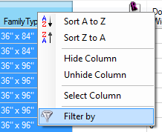 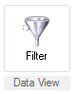

Mouse-right-click on a column header will display “Filter by” menu item. This will directly navigate to Filter tab with the clicked column as a selected column name for filtering. Or, simply clicking Filter button will initialize the settings to start filtering.

**Disabling Filter**

Click Home button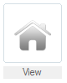 to move back to Home tab view or Cancel buttonon the right next to Filter button.

**Search by Keywords**

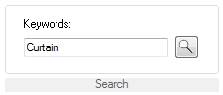

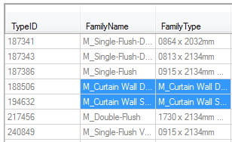

Enter any keywords in the textbox and click the Search button. If any data cells containing the keywords exist, they will be selected.

|  |  |
| --- | --- |
| Appendix A: Revit Hidden Properties (for instance tables only ) | |
| **Name** | **Description** |
| [FacingFlipped](mk:@MSITStore:C:\Revit%202013%20SDK\RevitAPI.chm::/html/85483f11-1f76-594b-d1cc-6acf8f4fc368.htm) | Property to test whether the orientation of family instance facing is flipped. |
| [FromRoom](mk:@MSITStore:C:\Revit%202013%20SDK\RevitAPI.chm::/html/d6658841-da29-ead4-049b-3036cbd4951a.htm) | The "From Room" set for the door or window in the last phase of the project. |
| [HandFlipped](mk:@MSITStore:C:\Revit%202013%20SDK\RevitAPI.chm::/html/7065faa0-00ac-93f1-427b-88496c53235e.htm) | Property to test whether the orientation of family instance hand is flipped. |
| [Host](mk:@MSITStore:C:\Revit%202013%20SDK\RevitAPI.chm::/html/69f30141-bd3b-8bdd-7a63-6353d4d495f9.htm) | If the instance is contained within another element, this property returns the containing element. An instance that is face hosted will return the element containing the face. |
| [IsSlantedColumn](mk:@MSITStore:C:\Revit%202013%20SDK\RevitAPI.chm::/html/14ca80b4-8cc8-2af7-3a72-db734b51eb79.htm) | Indicates if the family instance is a slanted column. |
| [Location](mk:@MSITStore:C:\Revit%202013%20SDK\RevitAPI.chm::/html/847ff799-9b1b-0982-f55a-7273c55b196d.htm) | This property is used to find the physical location of an instance within project.  (Overrides [Element..::..Location](mk:@MSITStore:C:\Revit%202013%20SDK\RevitAPI.chm::/html/89438f4f-7e15-835a-0c66-d6adbc8dd00c.htm).) |
| [Mirrored](mk:@MSITStore:C:\Revit%202013%20SDK\RevitAPI.chm::/html/20ab2f32-e3ca-8173-aac3-a03e998fd0ab.htm) | Property to test whether the family instance is mirrored. (only one axis is flipped) |
| [Room](mk:@MSITStore:C:\Revit%202013%20SDK\RevitAPI.chm::/html/37944e7a-f298-9c25-20bb-9c0c1da46f41.htm) | The room in which the instance is located (during the last phase of the project). |
| [ToRoom](mk:@MSITStore:C:\Revit%202013%20SDK\RevitAPI.chm::/html/939e9c7b-072a-7be9-105f-64e1aa1f3a97.htm) | The "To Room" set for the door or window in the last phase of the project. |

|  |
| --- |
| Appendix B: Access Database Description |
| KeyID (-114022;Doors;category): a common parameter in the Doors category  =>[*ParamID*];[*CategoryName*];category  KeyID (131017; 144220; family): a family specific parameter.  =>[*ParamID*];[*FamilyID*];family |
| 1. Inst_[*Category Name*]  - Contents: Revit data derived from family instances or system family elements  - Default System Fields: InstanceID, TypeID, FamilyID, FamilyName, FamilyType  - Internal Properties Fields: FacingFlipped (boolean), FromRoom (ElementId), HandFlipped (boolean), Host (ElementId), IsSlantedColumn (boolean), Mirrored (boolean), Room (ElementId), ToRoom (ElementId)  - Parameter Fields: [*Parameter Id*] **    **Field names cannot be same as parameter names.  When creating a field in Access programatically, only first 10 characters of field name can be recognized by Access class. For example, “DoorGlazingFrameWidth” and “DoorGlazingHeight” have equivalent 10 characters at the beginning, they are regared as duplicate fields when trying to create fields with those two names within a table.  To prevent this issue, field name has been altered to parameter id. |

|  |
| --- |
| Appendix C: Category Definition |
| Category Name: Views  Area Plans, Ceiling Plans, ~~Graphic Column Schedule~~ (excluded), Detail Views, Drafting Views, Sheets, Elevations, ~~Structural Plans (Revit Structure)~~ (excluded), Floor Plans, Legends, ~~Reports (Revit MEP)~~ (excluded), ~~Renderings~~ (excluded), ~~Reports~~ (excluded), ~~Schedules/Quantities~~ ~~(~~excluded), Sections, 3D Views, ~~Walkthroughs~~ (excluded) |
| Appendix D: Revit Element Category |
| - Area**  - Ceilings ( System Family)  - Curtain Panels ( System Family)  - Doors (Component Family)  - Floors (System Family)  - Furnitures (Component Family)  - Furniture Systems (Component Family)  - Generic Model (Component Family)  - Mass (Component Family)  - Railings (System Family)  - Ramps (System Family)  - Roof (System Family)  - Rooms**  - Spaces**  - Specialty Equipment (Component Family)  - Stairs (System Family)  - Structural Foundation (System Family)  - Views**  - Walls (System Family)  - Windows (Component Family)  ** non-families treated as different structures of data |
| Appendix E: Revit Value AsString( ) vs AsDouble( ) |
| 1. User interface in the Data Editor vs Tagged values   |  | | --- | | Tag: FurnitureSystemDepth | | 2.00 | | 1.50 | | 0.25 |     2. When Math calculation includes the FurnitureSystemDepth, a new double value field will be created in the database.  Additional FurnitureSystemDepth=[FurnitureSystemDepth]+0.5  <Data Editor>    <Database>    1154932: parameter Id of FurnitureSystemDepth |